**Striver Math Series**

**Digit Concept –**

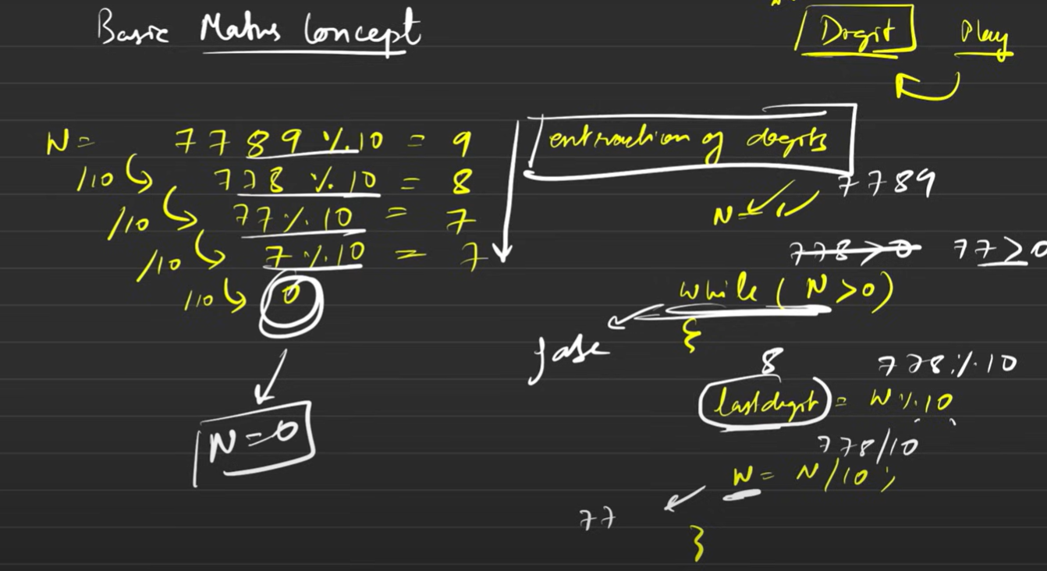

**Count of Digits**

